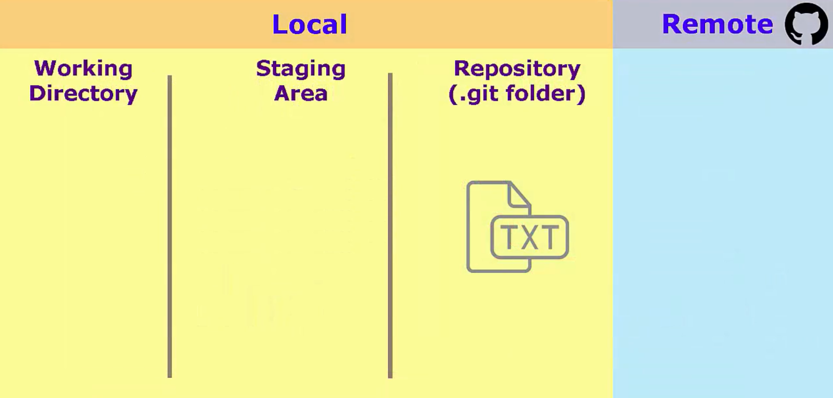
WORKING Directory – Folder on the computer with all the project files
STAGING Area – Holding area for queuing up changes for the next commit. Pre-commit area
Repository -Commit
Master Branch – timeline

COMMANDS :
pwd - Print Working Directory'. As the name states, command 'pwd' prints the current working directory or simply the directory user is, at present
mkdir - function creates a new, empty directory whose name is defined by path. (Creates a new folder within the current folder that you are in)
cd: - The cd command will allow you to change directories. When you open a terminal you will be in your home directory. To move around the file system you will use cd. Examples:
To navigate into the root directory, use "cd /"
To navigate to your home directory, use "cd" or "cd ~"
To navigate up one directory level, use "cd .."
To navigate to the previous directory (or back), use "cd -"
To navigate through multiple levels of directory at once, specify the full directory path that you want to go to. For example, use, "cd /var/www" to go directly to the /www subdirectory of /var/. As another example, "cd ~/Desktop" will move you to the Desktop subdirectory inside your home directory.
To set up our local system info:
git config - -global user.name “imie nazwisko”
git config - -global user.email “email”
git config - -global - -list

